**QUESTION 02 – PART 04**

1. **QUERY:**  
   SELECT * FROM Students;  
     
   **RESULT:**  
   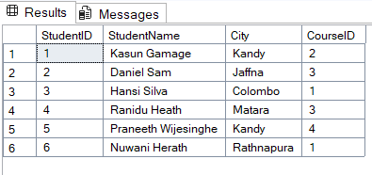
2. **QUERY:**  
   SELECT StudentID, StudentName, City FROM Students WHERE City='Kandy';  
     
   **RESULT:**  
   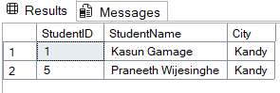
3. **QUERY:**  
   UPDATE Students SET City='Galle' WHERE StudentID='4';  
     
     
     
     
     
     
     
     
     
     
     
     
     
   **RESULT:**  
   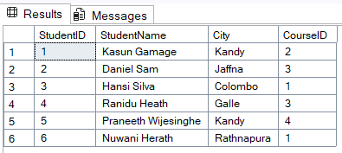
4. **QUERY:**  
   SELECT Students.StudentID, StudentName, City, Courses.CourseName  
   FROM Students, Courses  
   WHERE Students.CourseID = Courses.CourseID;  
     
   **RESULT:**  
   